**Project Design Phase-II**

**Data Flow Diagram & User Stories**

|  |  |
| --- | --- |
| Date | 12 October 2022 |
| Team ID | IBM-Project-10558-1659186640 |
| Project Name | Deep Learning Fundus Image Analysis for Early Detection of Diabetic Retinopathy |
| Maximum Marks | 4 Marks |

**Data Flow Diagrams:**

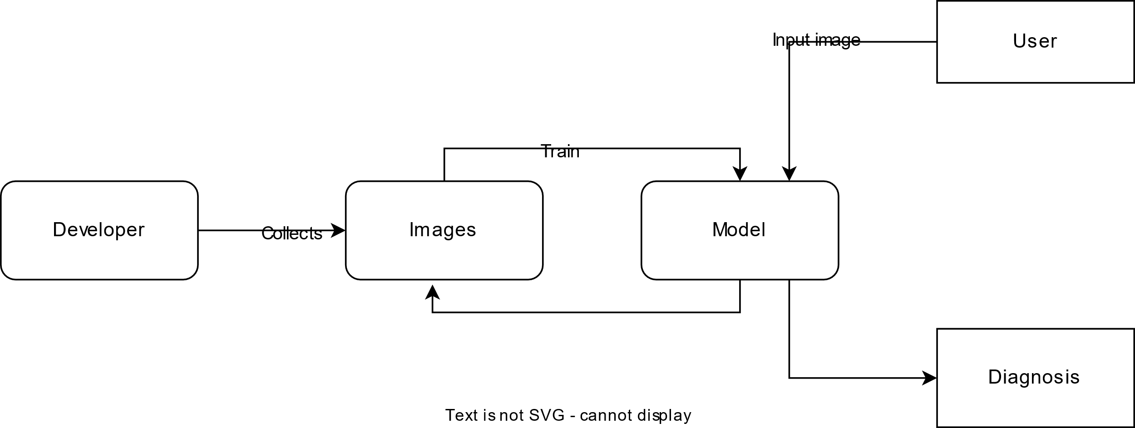

**User Stories**

| **User Type** | **Functional Requirement (Epic)** | **User Story Number** | **User Story / Task** | **Acceptance criteria** | **Priority** | **Release** |
| --- | --- | --- | --- | --- | --- | --- |
| Common User | Dashboard | USN-1 | As a user, I can I must be able to upload image of my eyes | I can upload or take image | High | Sprint-1 |
|  |  | USN-2 | As a user, I will receive the diagnosis as to whether I have retinopathy or not | I can receive the diagnosis | High | Sprint-1 |
|  |  | USN-3 | As a user, I receive the severity of the retinopathy | I can receive the severity of the retinopathy | Medium | Sprint-2 |
|  |  | USN-4 | As a user, I can receive the suggested remedy | I can receive the suggested remedy | Medium | Sprint-2 |